Quin Charl Barnard
#27902277
Mr. Mfuno Didi
11 April 2025
Syntax assignment
General Linguistics 278

GLOSSARY:
The following abbreviations will be used throughout the assignment:
AdjP -Adjectival Phrase
AdvP -Adverbial Phrase
D - Determiner
DP - Determiner Phrase
N -Noun
NP -Noun Phrase
T -Tense
TP -Tense Phrase
V -Verb
VP -Verb Phrase
P -Preposition
PP -Prepositional Phrase
Furthermore, when a tense is only indicated as (SIMPLE) or (PAST) with no other specification, it is Simple Present- or Simple Past tense, as opposed to, for example, Continuous Present- or Continuous Past Tense.

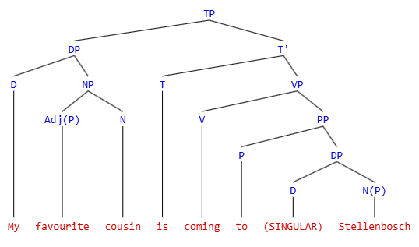
SECTION 1:
a.) My favourite cousin is coming to Stellenbosch.

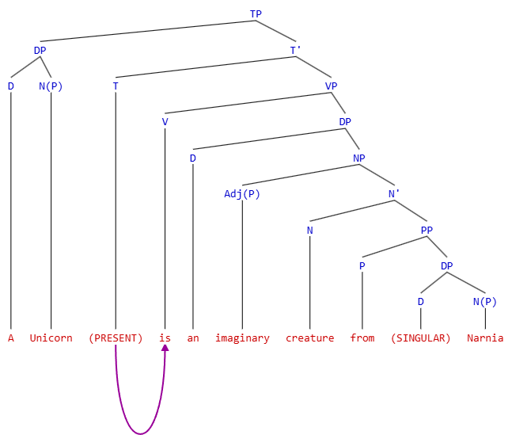
b.) A Unicorn is an imaginary creature from Narnia.
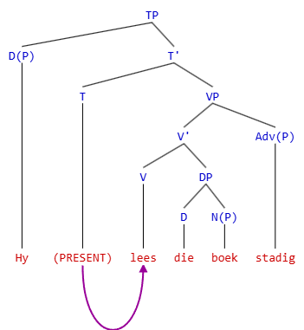
c.) Hy lees die boek stadig.
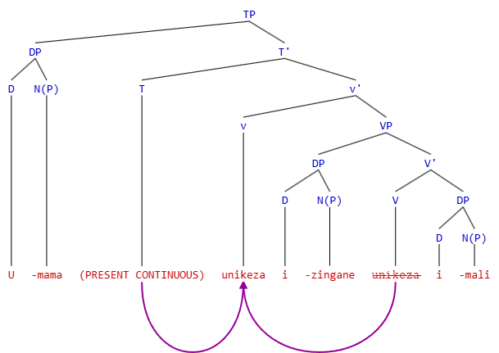
SECTION 2:
a.) Umama unikeza izingane imali.
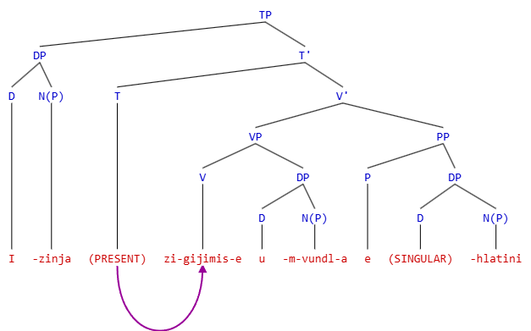
b.) Izinja zigijimise umvundla ehlatini.
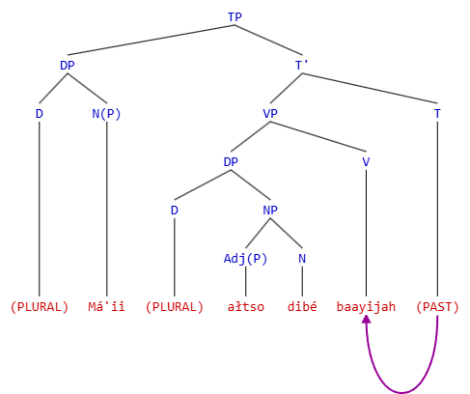
SECTION 3:
a.) Má’ii ałtso dibé baayijah.
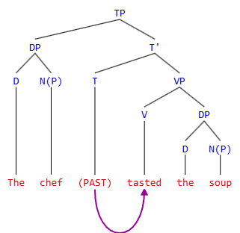
Section 4:
a.) The chef tasted the soup.
Step 1: The determiner “the” merges with the noun “soup” to derive the object Noun Phrase (indicated above and referred to henceforth as Determiner Phrase/DP).
Step 2: The object DP merges with the verb “to taste” to derive the Verb Phrase.
Step 3: The Tense node projects its tense-property, with a value of [PAST] onto the head of the VP, the verb “to taste.” The tense node now merges with VP to derive the predicate, indicated above by “ T’ ”. This completes the predicate of the sentence, which is now: “tasted the soup”
Step 4: The determiner “The” merges with the noun “chef” to derive the subject DP (alternatively: NP). The subject is now complete, “The chef”.
Step 5: The subject DP merges with the predicate, indicated above by “ T’ ”, to derive a complete Tense Phrase, thus completing a full grammatical sentence.

